https://www.javatpoint.com/keras-recurrent-neural-networks

Recurrent Neural Networks

Why not Feedforward Networks?
Feedforward networks are used to classify images. Let us understand the concept of a feedforward network with an example given below in which we trained our network for classifying various images of animals. If we feed an image of a cat, it will identify that image and provide a relevant label to that particular image. Similarly, if you feed an image of a dog, it will provide a relevant label to that image a particular image as well.
Consider the following diagram:
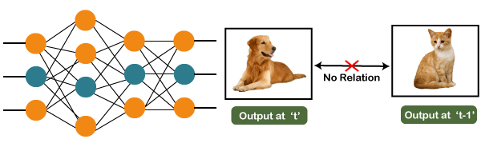
And if you notice the new output that we have got is classifying, a dog has no relation to the previous output that is of a cat, or you can say that the output at the time 't' is independent of output at a time 't-1'. It can be clearly seen that there is no relation between the new output and the previous output. So, we can say that in feedforward networks, the outputs are independent of each other.
There are a few scenarios where we will actually need the previous output to get the new output. Let us discuss one such scenario where we will necessitate using the output that has been previously obtained.
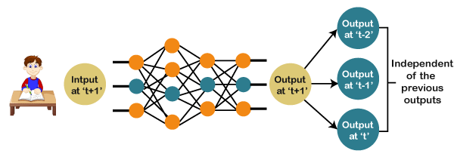
Now, what happens when you read a book. You will understand that book only on the understanding of the previous words. So, if we use a feedforward network and try to predict the next word in the sentence, then in such a case, we will not be able to do that because our output will actually depend on previous outputs. But in the feedforward network, the new output is independent of the previous outputs, i.e., output at 't+1' has no relation with the output at 't-2', 't-1', and 't.' Therefore, it can be concluded that we cannot use feedforward networks for predicting the next word in the sentence. Similarly, many other examples can also be taken where we need the previous output or some information from the previous output, so as to infer the new output.
How to overcome this challenge?
Consider the following diagram:
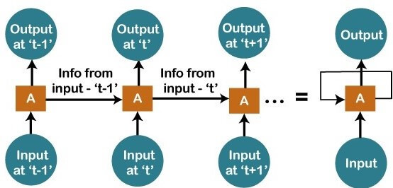
We have input at 't-1', which we will feed to the network, and then we will get the output at 't-1'. Then at the next timestamp that is at a time 't', we have an input at a time 't', which will be again given to the network along with the information from the previous timestamp, i.e., 't-1' and that will further help us to get the output at 't'. Similarly, at the output for 't+1', we have two inputs; one is the new input that we give, and the other is the information coming from the previous timestamps, i.e., 't' in order to get the output at a time 't+1'. In the same way, it will go on further like this. Here we have embodied in a more generalized way to represent it. There is a loop where the information from the previous timestamp is flowing, and this is how we can solve a particular challenge.
What are Recurrent Neural Networks?
"Recurrent Networks are one such kind of artificial neural network that are mainly intended to identify patterns in data sequences, such as text, genomes, handwriting, the spoken word, numerical times series data emanating from sensors, stock markets, and government agencies".
In order to understand the concept of Recurrent Neural Networks, let's consider the following analogy.
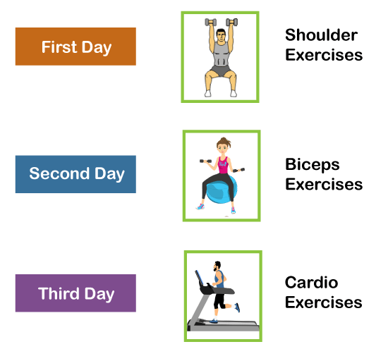
Suppose that your gym trainer has made a schedule for you. The exercises are repeated every third day. The above image includes the order of your exercises; on your very first day, you will be doing shoulders, the second day you will be doing biceps, the third day you will be doing cardio, and all these exercises are repeated in proper order.
Let's see what happens if we use a feedforward network for predicting the exercises today.
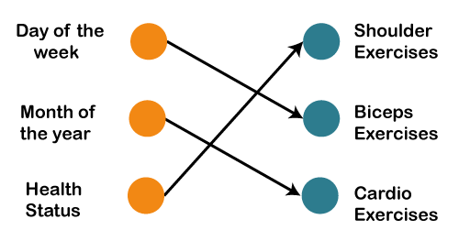
We have provided in the input such as day of the week, the month of the year, and health status. Also, we need to train our model or the network on the basis of the exercises that we have done in the past. After that, there will be a complex voting procedure involved, which will predict the exercises for us, and that procedure won't be that accurate. In that case, whatever output we will get would be as accurate as we want it to be. Now, what if the inputs get changed, and we make the inputs as the exercises that we have done the previous day.
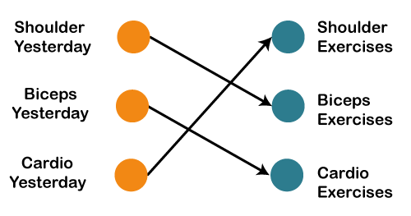
Therefore, if shoulders were done yesterday, then definitely today will be biceps day. Similarly, if biceps were done yesterday, then today will be the cardio day, and if yesterday was the cardio day, then today, we will need to undergo shoulder.
Now there can be one such scenario, where you are unable to go to the gym for one day due to some personal reasons, then it that case, we will go one timestamp back and will feed in what exercise happened day before yesterday as shown below.
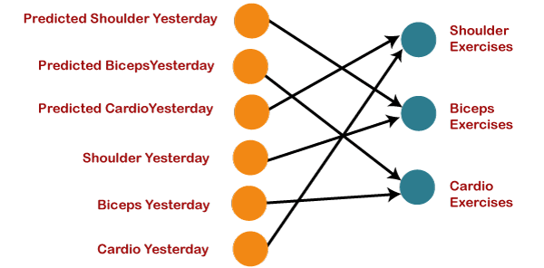
So, if the exercise that happened the day before yesterday was the shoulder, then yesterday there were biceps exercises. Similarly, if biceps happened the day before yesterday, then yesterday would have been cardio exercises, and if cardio would have happened the day before yesterday, then yesterday would have been shoulder exercises. And this prediction for the exercises that happened yesterday will be fed back to our network so that these predictions can be used as inputs in order to predict what exercise will happen today. Similarly, if you have missed your gym say for two days, three days or even one week, you will actually need to roll back, which means that you will need to go to the last day when you went to the gym, you need to figure out what exercises you did on that day and then only you will be getting the relevant output as to what exercises will happen today.
Next, we will convert all these things into a vector, which is nothing but a list of numbers.
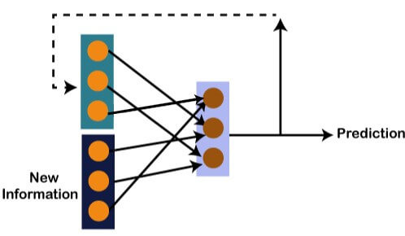
So, there is new information along with the information which we got from the prediction at the previous timestamp because we need all of these in order to get the prediction at a time 't'. Imagine that you did shoulder exercises yesterday, then, in that case, the prediction will be biceps exercise because if the shoulder was done yesterday, then today it will definitely be biceps and output will be 0, 1, and 0, which is actually the work of our vectors.
Let's understand the math behind the Recurrent Neural Network by simply having a look at the image given below.
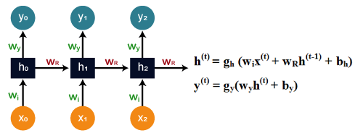
Assume that 'w' is the weight matrix, and 'b' is the bias. Consider at time t=0, our input is 'x_{o}', and we need to figure out what exactly is the 'h_{o}'. We will substitute t=0 in the equation, as shown in the image, so as to procure the function h^{t} value.
After that, we will find out the value of 'y_{o}' by using values that were previously calculated when we applied it to the new formula.
The same process is repeated again and again through all the timestamps within the model so as to train it. So, this how a Recurrent Neural Networks works.
Training a Recurrent Neural Network
A recurrent neural network uses a backpropagation algorithm for training, but backpropagation happens for every timestamp, which is why it is commonly called as backpropagation through time. With backpropagations, there are certain issues, namely vanishing and exploding gradients, that we will see one by one.
Vanishing Gradient
Consider the following diagram:
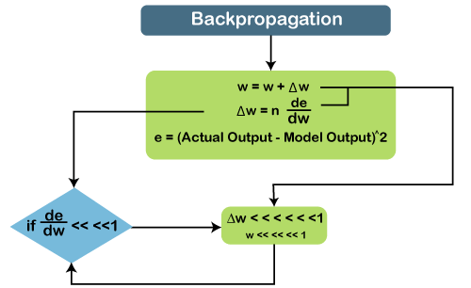
In vanishing gradient when we use backpropagation, we tend to calculate the error which is nothing but the actual output that we already know subtracted by the model output that we got through the model and the square of that, so we can figure out the error, and with the help of that error, we tend to find out the change in error with respect to change in weight or any variable, which is here called as weight.
So, the change of error with respect to change in weight multiplied by learning rate will give us the change in rate. And then we will add this change in weight to the old weight to get a new weight. Basically, here we are trying to reduce the error, and for that, we need to figure out what will be the change in error if variables get changed, by which we can get the change in the variable and add it to our old variable to get the new variable.
Now over here what can happen if the value de⁄dw, i.e., gradient or simply we can say the rate of change of error with respect to weight variable becomes very smaller than 1 and if we multiply that with the learning rate, which is the definitely smaller than 1, then, in that case, we will get the change in weight, which is negligible.
Consider a scenario where you need to predict the next word in the sentence, and your sentence is something like "I have been to USA". Then are a lot of words after that few people speak, and then you need to predict what comes after speak. Now, if you need to do that, then you will have to go back and understand the context of what it is talking about, which is nothing but our long-term dependencies. During the long-term dependencies, de⁄dw becomes very small, and then when you multiply it with n, which is again smaller than 1, you get Δw, which will be very small or simply negligible. So, the new weight that you will get here will be almost equal to your old weight, such that the weight will not get updated further. Also, there will be no learning here, which is nothing but the problem of vanishing gradient.
Exploding Gradient
Similarly, if we talk about the exploding gradient, it is actually opposite to that of the vanishing gradient. Consider the below diagram to have a better understanding of it.
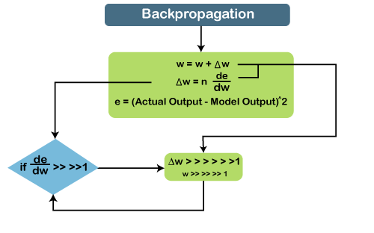
If de⁄dw becomes very large or greater than 1 and we have some long-term dependencies, then, in that case, de⁄dw will keep on increasing, and Δw will become very large that will make the new weight different than that of the old weights. So, these were the two problems with backpropagation, and now we will see how to solve these problems.
How to overcome these challenges?
Exploding Gradients | Vanishing Gradients
The exploding gradient can be solved with the help of Truncated BTT backpropagation through time, so instead of staring backpropagation as the last timestamp, we can choose some smaller timestamps like 10. | For vanishing gradient, we can make use of the ReLU activation function that results in the output while calculating the gradient.
Also, we can clip the gradients at the threshold. So, there can be a threshold value where we can clip the gradients. | We can also integrate RMSprop for clipping the gradient when it goes higher than the threshold.
We also adjust the learning rate as well with the RMSprop. | Similarly, LSTM and GRUs can also be incorporated that are specially designed network architectures as these are made to combat this problem.
Long Short-Term Memory Networks (LSTMs)
Long Short-Term Memory networks, which are commonly known as "LSTMs," are a special kind of Recurrent Neural Networks that are capable enough of learning long-term dependencies.
What are long-term dependencies?
It has happened many times that we only require recent data in order to perform questions in a model. But at the same time, we may also need data that has been previously obtained.
Consider the following example to have a better understanding of it.
Let's suppose there is a language model, which is trying to predict the next word on the basis of the previous ones. Assume that we are trying to predict the last word in the sentence say, "The car runs on the road".
Here the context is quite simple because the last word always ends up being a road. By incorporating Recurrent Neural Networks, the gap present between the former information and the existing necessities can be easily associated.
That is the reason why Vanishing and Exploding Gradient problems do not exist, followed by making this LSTM networks to easily handle long-term dependencies.
LSTM encompasses a layer of neural network in the form of a chain. In a standard recurrent neural network, the repeating module consists of one single function as shown in the image given below:
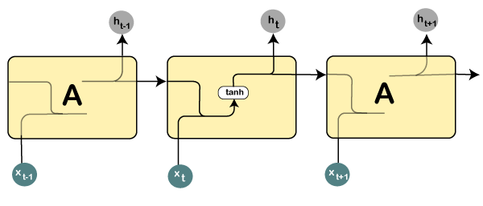
From the image given above, it can be seen that there is a tanh function in the layer, which is called as squashing function. So, what is a squashing function?
The squashing function is mainly used in between the range of -1 to +1 so that the values can be manipulated on the basis of inputs.
Now, let us consider the structure of an LSTM network:
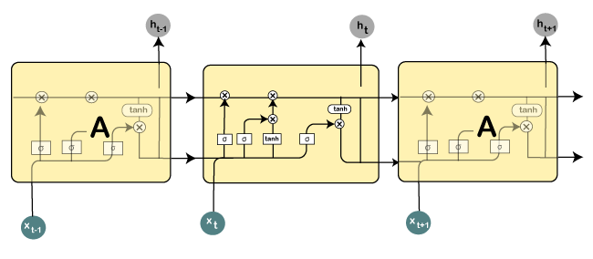
Here all those functions that are present in the layers have their own structures as and when it comes to LSTM networks. The cell state is represented by the horizontal line, acts as a conveyer belt that carries the data linearly crossways the data channel.
Let us consider a step-by-step approach to understand LSTM networks better.
Step 1:
The first step in the LSTM is to identify that information which is not required and will be thrown away from the cell state. This decision is made by a sigmoid layer, which called the forget gate layer.
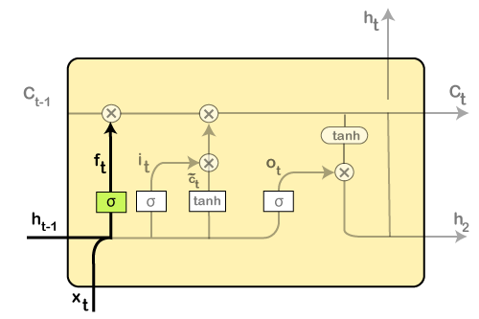
The highlighted layer in the above is the sigmoid layer which is previously mentioned.
The calculation is done by considering the new input, and the previous timestamp is, which eventually leads to the output of a number between 0 and 1 for each number in that cell state.
As a typical binary, 1 represents to keep the cell state while 0 represents to trash it.
f_{t} = σ(w_{f} [h_{t-1}, x_{t}] + b_{f})
where, w_{f} = Weight
h_{t-1} = Output from previous timestamp
x_{t} = New input
b_{f} = Bias
Considering a gender classification problem, it necessitates observing the correct gender when we are using the network.

Step 2:
Next, we will decide which information we will store in the cell state. It further consists of the following steps:
- The sigmoid layer, which is also known as the "input gate layer," will make decisions about those values that are needed to be updated.
- A vector of new candidate values is created so that they can be added to the state by the tanh layer.
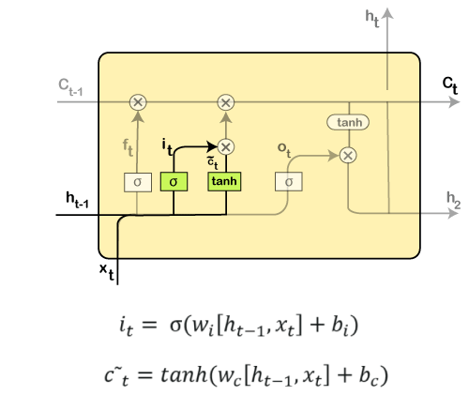
Then the new input, as well as the preceding timestamp's input, will get passed through a sigmoid function that will result in the value i(t), which will then be multiplied by c(t) followed by adding it to the cell state.
In the next step, we will combine both of them so as to update the state.
Step 3:
In the 3rd step, the previous cell state Ct-1 will get updated into the new cell state Ct.
And for that, we will need to multiply the old state (Ct-1) by f(t), keeping the things aside that we thought that we earlier decided to leave.
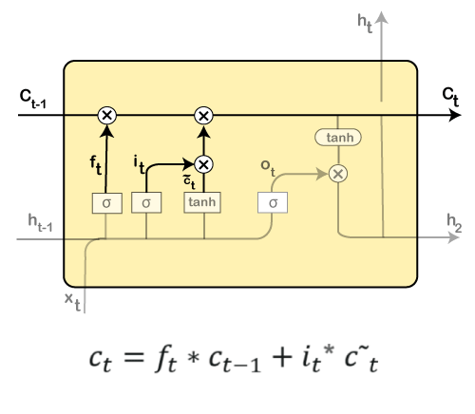
Next, we will add i_t* c˜_t, which is the new candidate values. It has been actually scaled by how much we wanted to update each state value.
In the second step, we decided to do make use of the data, which is only required at that stage. However, in the third step, we have executed it.
Step 4:
In the 4th step, we will run the sigmoid layer that will decide for those parts of the cell state that will result in the output.
Next, we will put the cell state through tanh, which means we will be pushing the values in between the range of -1 and 1.
And then, further, we will multiply it with the sigmoid gate's output so that only the decided parts results in the output.
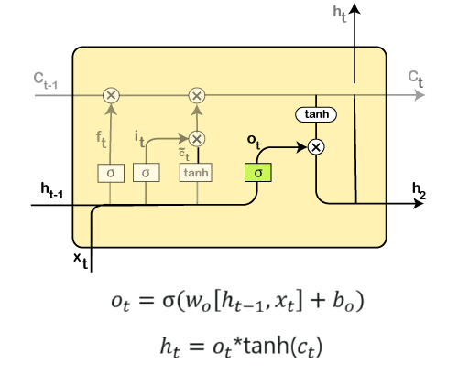
In this step, we will be doing some calculations that will result in the output.
However, the output consists of only the outputs there were decided to be carry forwarded in the previous steps and not all the outputs at once.
A Quick Recap:
- At first, we find out what is to be dropped.
- Then in the second step, it included newly added inputs to the network.
- In the third step, the earlier obtained inputs get combined in order to produce the new cell states.
- Lastly, we arrived at the output as per requirement.
**** Nice example of building RNN is given at the end. Check it for practical.

https://colah.github.io/posts/2015-08-Understanding-LSTMs/

Understanding LSTM Networks
Recurrent Neural Networks
Humans don’t start their thinking from scratch every second. As you read this essay, you understand each word based on your understanding of previous words. You don’t throw everything away and start thinking from scratch again. Your thoughts have persistence.
Traditional neural networks can’t do this, and it seems like a major shortcoming. For example, imagine you want to classify what kind of event is happening at every point in a movie. It’s unclear how a traditional neural network could use its reasoning about previous events in the film to inform later ones.
Recurrent neural networks address this issue. They are networks with loops in them, allowing information to persist.
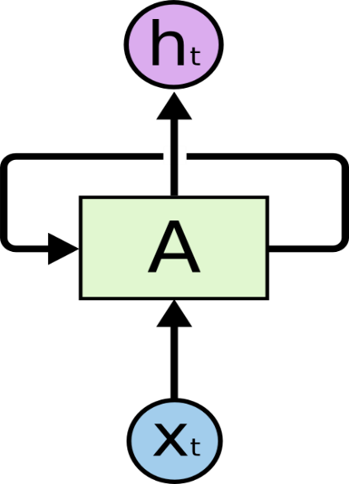
Recurrent Neural Networks have loops.
In the above diagram, a chunk of neural network, AA, looks at some input xtxt and outputs a value htht. A loop allows information to be passed from one step of the network to the next.
These loops make recurrent neural networks seem kind of mysterious. However, if you think a bit more, it turns out that they aren’t all that different than a normal neural network. A recurrent neural network can be thought of as multiple copies of the same network, each passing a message to a successor. Consider what happens if we unroll the loop:
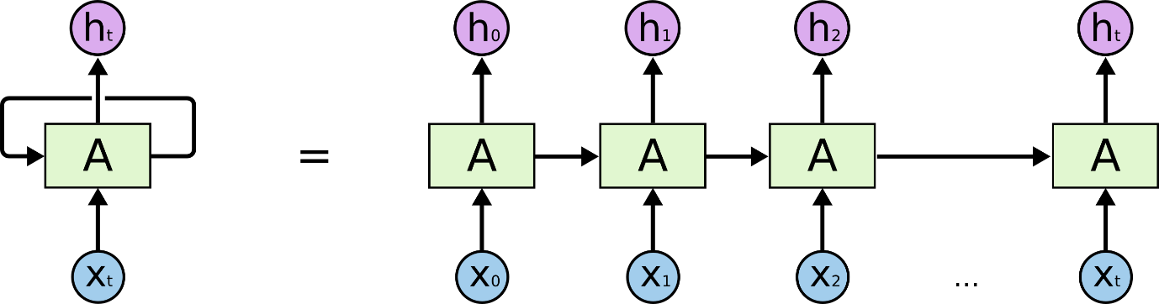
An unrolled recurrent neural network.
This chain-like nature reveals that recurrent neural networks are intimately related to sequences and lists. They’re the natural architecture of neural network to use for such data.
And they certainly are used! In the last few years, there have been incredible success applying RNNs to a variety of problems: speech recognition, language modeling, translation, image captioning… The list goes on. I’ll leave discussion of the amazing feats one can achieve with RNNs to Andrej Karpathy’s excellent blog post, The Unreasonable Effectiveness of Recurrent Neural Networks. But they really are pretty amazing.
Essential to these successes is the use of “LSTMs,” a very special kind of recurrent neural network which works, for many tasks, much much better than the standard version. Almost all exciting results based on recurrent neural networks are achieved with them. It’s these LSTMs that this essay will explore.
The Problem of Long-Term Dependencies
One of the appeals of RNNs is the idea that they might be able to connect previous information to the present task, such as using previous video frames might inform the understanding of the present frame. If RNNs could do this, they’d be extremely useful. But can they? It depends.
Sometimes, we only need to look at recent information to perform the present task. For example, consider a language model trying to predict the next word based on the previous ones. If we are trying to predict the last word in “the clouds are in the sky,” we don’t need any further context – it’s pretty obvious the next word is going to be sky. In such cases, where the gap between the relevant information and the place that it’s needed is small, RNNs can learn to use the past information.
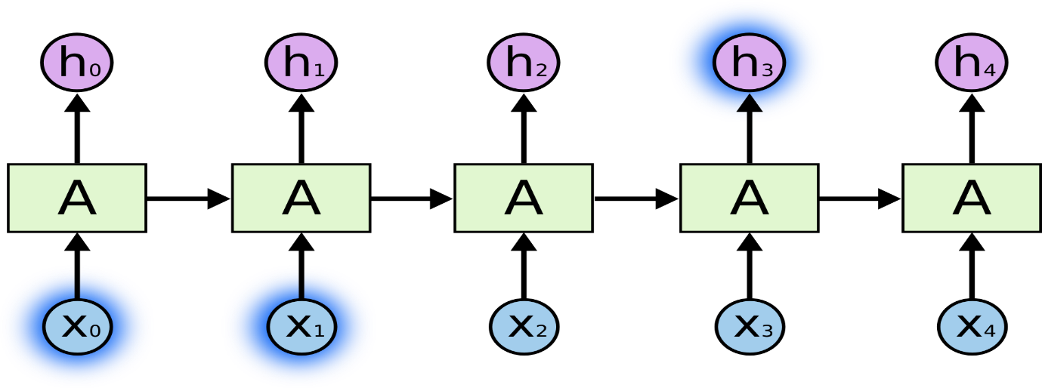
But there are also cases where we need more context. Consider trying to predict the last word in the text “I grew up in France… I speak fluent French.” Recent information suggests that the next word is probably the name of a language, but if we want to narrow down which language, we need the context of France, from further back. It’s entirely possible for the gap between the relevant information and the point where it is needed to become very large.
Unfortunately, as that gap grows, RNNs become unable to learn to connect the information.
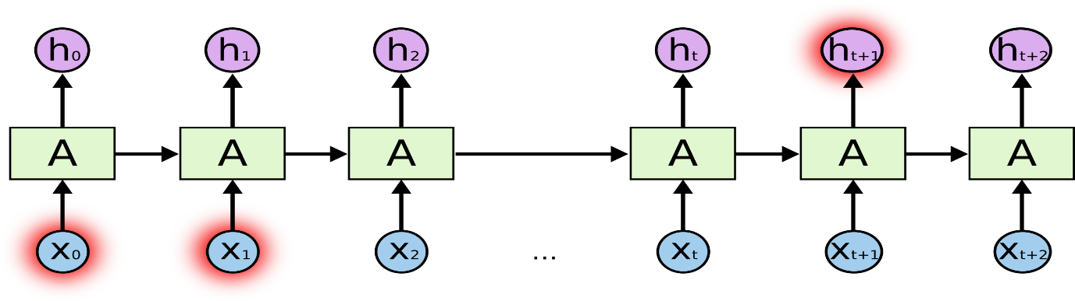
In theory, RNNs are absolutely capable of handling such “long-term dependencies.” A human could carefully pick parameters for them to solve toy problems of this form. Sadly, in practice, RNNs don’t seem to be able to learn them. The problem was explored in depth by Hochreiter (1991) [German] and Bengio, et al. (1994), who found some pretty fundamental reasons why it might be difficult.
Thankfully, LSTMs don’t have this problem!
LSTM Networks
Long Short-Term Memory networks – usually just called “LSTMs” – are a special kind of RNN, capable of learning long-term dependencies. They were introduced by Hochreiter & Schmidhuber (1997), and were refined and popularized by many people in following work.¹ They work tremendously well on a large variety of problems, and are now widely used.
LSTMs are explicitly designed to avoid the long-term dependency problem. Remembering information for long periods of time is practically their default behavior, not something they struggle to learn!
All recurrent neural networks have the form of a chain of repeating modules of neural network. In standard RNNs, this repeating module will have a very simple structure, such as a single tanh layer.
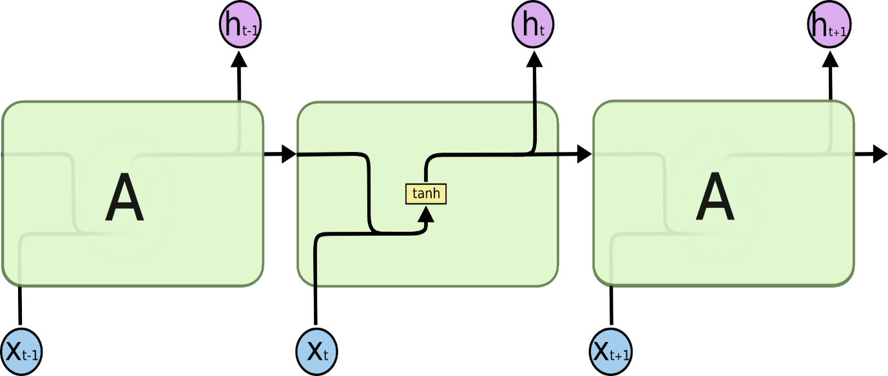
The repeating module in a standard RNN contains a single layer.
LSTMs also have this chain like structure, but the repeating module has a different structure. Instead of having a single neural network layer, there are four, interacting in a very special way.

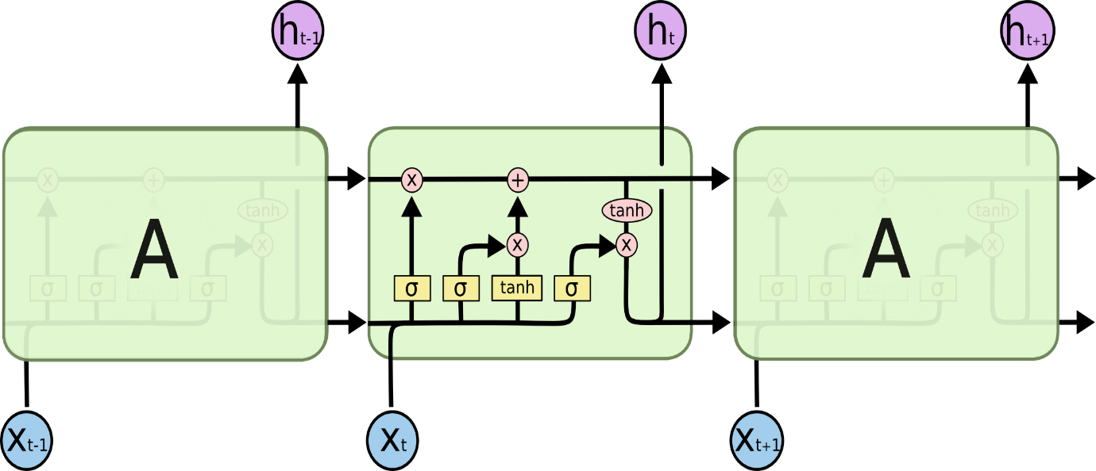
The repeating module in an LSTM contains four interacting layers.
Don’t worry about the details of what’s going on. We’ll walk through the LSTM diagram step by step later. For now, let’s just try to get comfortable with the notation we’ll be using.
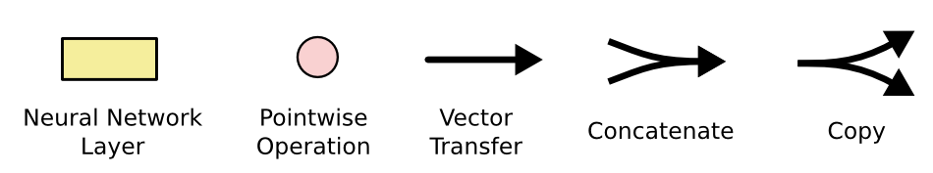
In the above diagram, each line carries an entire vector, from the output of one node to the inputs of others. The pink circles represent pointwise operations, like vector addition, while the yellow boxes are learned neural network layers. Lines merging denote concatenation, while a line forking denote its content being copied and the copies going to different locations.
Step-by-Step LSTM Walk Through
The first step in our LSTM is to decide what information we’re going to throw away from the cell state. This decision is made by a sigmoid layer called the “forget gate layer.” It looks at ht−1ht−1 and xtxt, and outputs a number between 00 and 11 for each number in the cell state Ct−1Ct−1. A 11 represents “completely keep this” while a 00 represents “completely get rid of this.”
Let’s go back to our example of a language model trying to predict the next word based on all the previous ones. In such a problem, the cell state might include the gender of the present subject, so that the correct pronouns can be used. When we see a new subject, we want to forget the gender of the old subject.
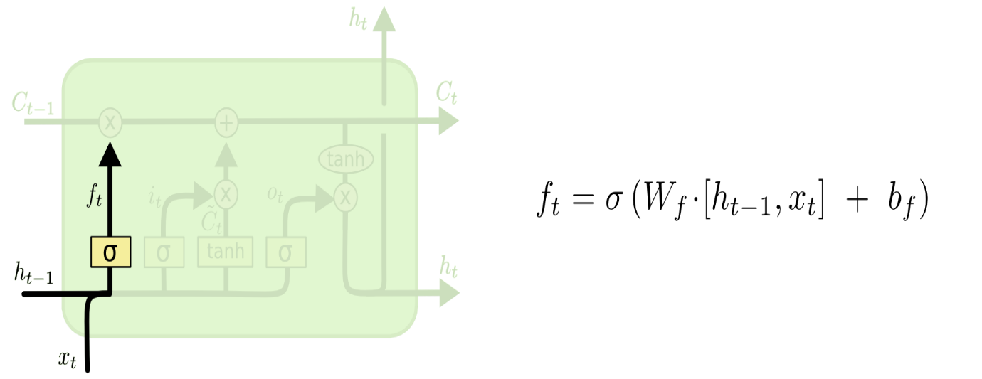
The next step is to decide what new information we’re going to store in the cell state. This has two parts. First, a sigmoid layer called the “input gate layer” decides which values we’ll update. Next, a tanh layer creates a vector of new candidate values, C~tC~t, that could be added to the state. In the next step, we’ll combine these two to create an update to the state.
In the example of our language model, we’d want to add the gender of the new subject to the cell state, to replace the old one we’re forgetting.
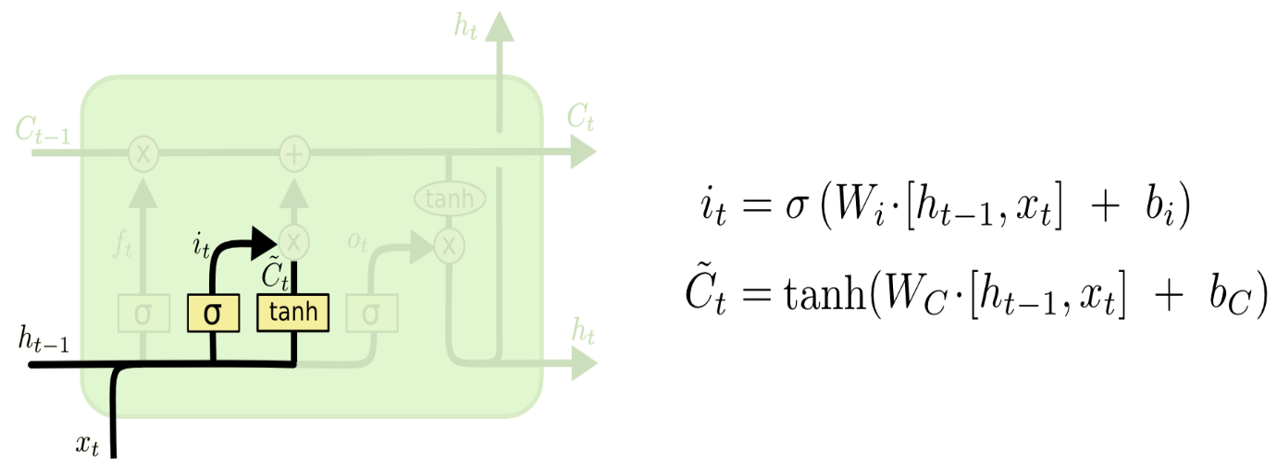
It’s now time to update the old cell state, Ct−1Ct−1, into the new cell state CtCt. The previous steps already decided what to do, we just need to actually do it.
We multiply the old state by ftft, forgetting the things we decided to forget earlier. Then we add it∗C~tit∗C~t. This is the new candidate values, scaled by how much we decided to update each state value.
In the case of the language model, this is where we’d actually drop the information about the old subject’s gender and add the new information, as we decided in the previous steps.
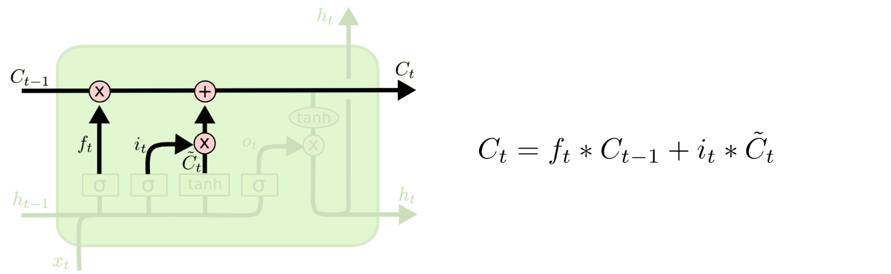
Finally, we need to decide what we’re going to output. This output will be based on our cell state, but will be a filtered version. First, we run a sigmoid layer which decides what parts of the cell state we’re going to output. Then, we put the cell state through tanhtanh (to push the values to be between −1−1 and 11) and multiply it by the output of the sigmoid gate, so that we only output the parts we decided to.
For the language model example, since it just saw a subject, it might want to output information relevant to a verb, in case that’s what is coming next. For example, it might output whether the subject is singular or plural, so that we know what form a verb should be conjugated into if that’s what follows next.
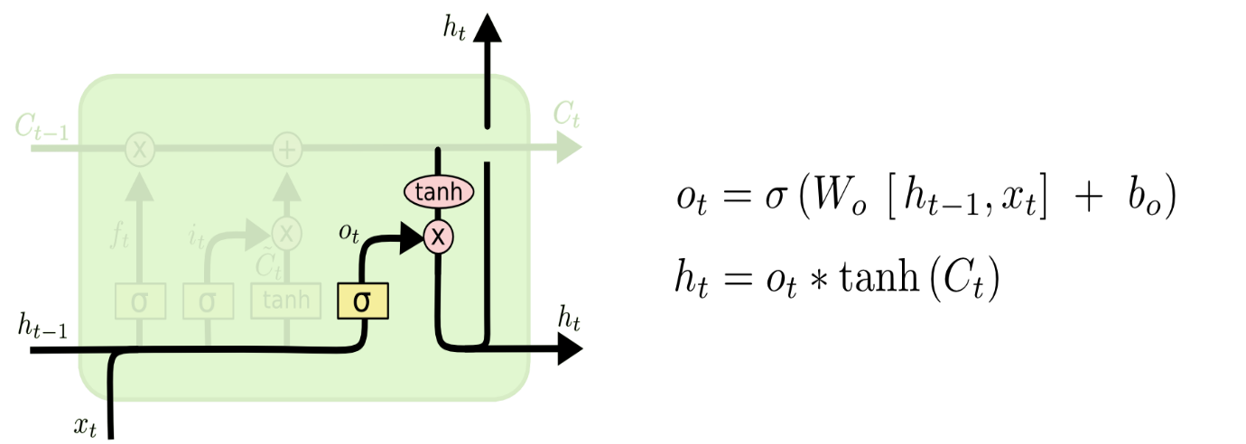
Variants on Long Short Term Memory
What I’ve described so far is a pretty normal LSTM. But not all LSTMs are the same as the above. In fact, it seems like almost every paper involving LSTMs uses a slightly different version. The differences are minor, but it’s worth mentioning some of them.
One popular LSTM variant, introduced by Gers & Schmidhuber (2000), is adding “peephole connections.” This means that we let the gate layers look at the cell state.
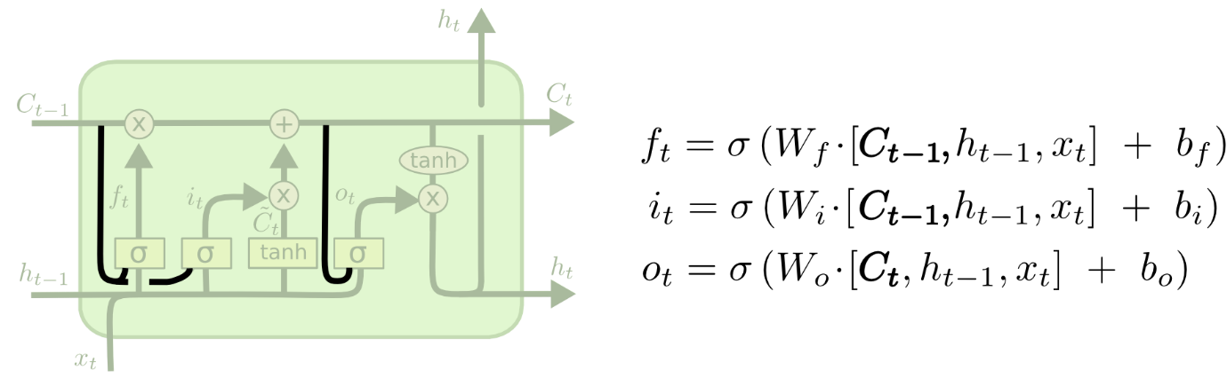
The above diagram adds peepholes to all the gates, but many papers will give some peepholes and not others.
Another variation is to use coupled forget and input gates. Instead of separately deciding what to forget and what we should add new information to, we make those decisions together. We only forget when we’re going to input something in its place. We only input new values to the state when we forget something older.
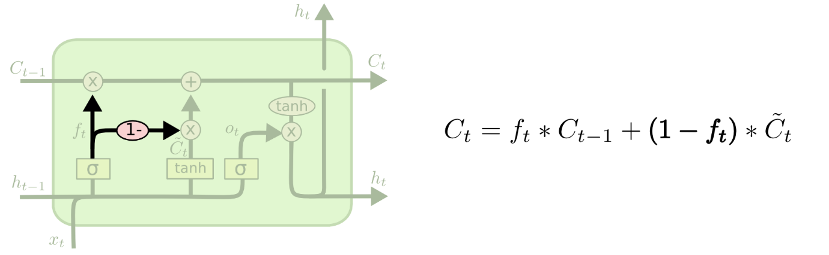
A slightly more dramatic variation on the LSTM is the Gated Recurrent Unit, or GRU, introduced by Cho, et al. (2014). It combines the forget and input gates into a single “update gate.” It also merges the cell state and hidden state, and makes some other changes. The resulting model is simpler than standard LSTM models, and has been growing increasingly popular.
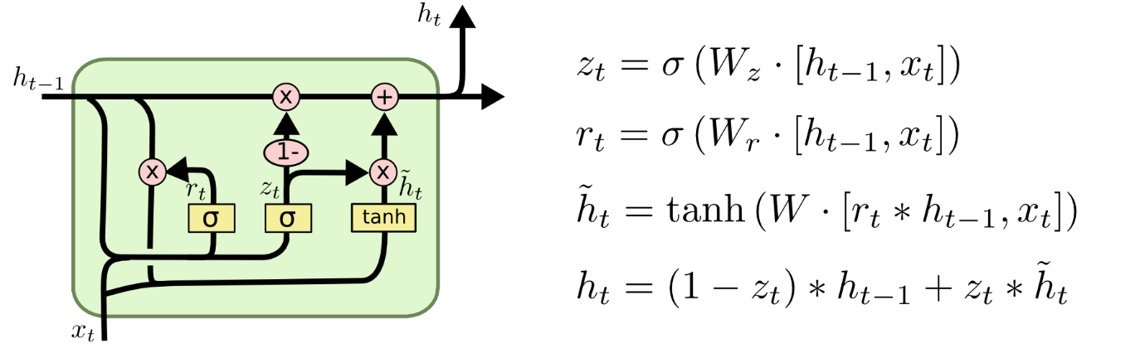
These are only a few of the most notable LSTM variants. There are lots of others, like Depth Gated RNNs by Yao, et al. (2015). There’s also some completely different approach to tackling long-term dependencies, like Clockwork RNNs by Koutnik, et al. (2014).
Which of these variants is best? Do the differences matter? Greff, et al. (2015) do a nice comparison of popular variants, finding that they’re all about the same. Jozefowicz, et al. (2015) tested more than ten thousand RNN architectures, finding some that worked better than LSTMs on certain tasks.

